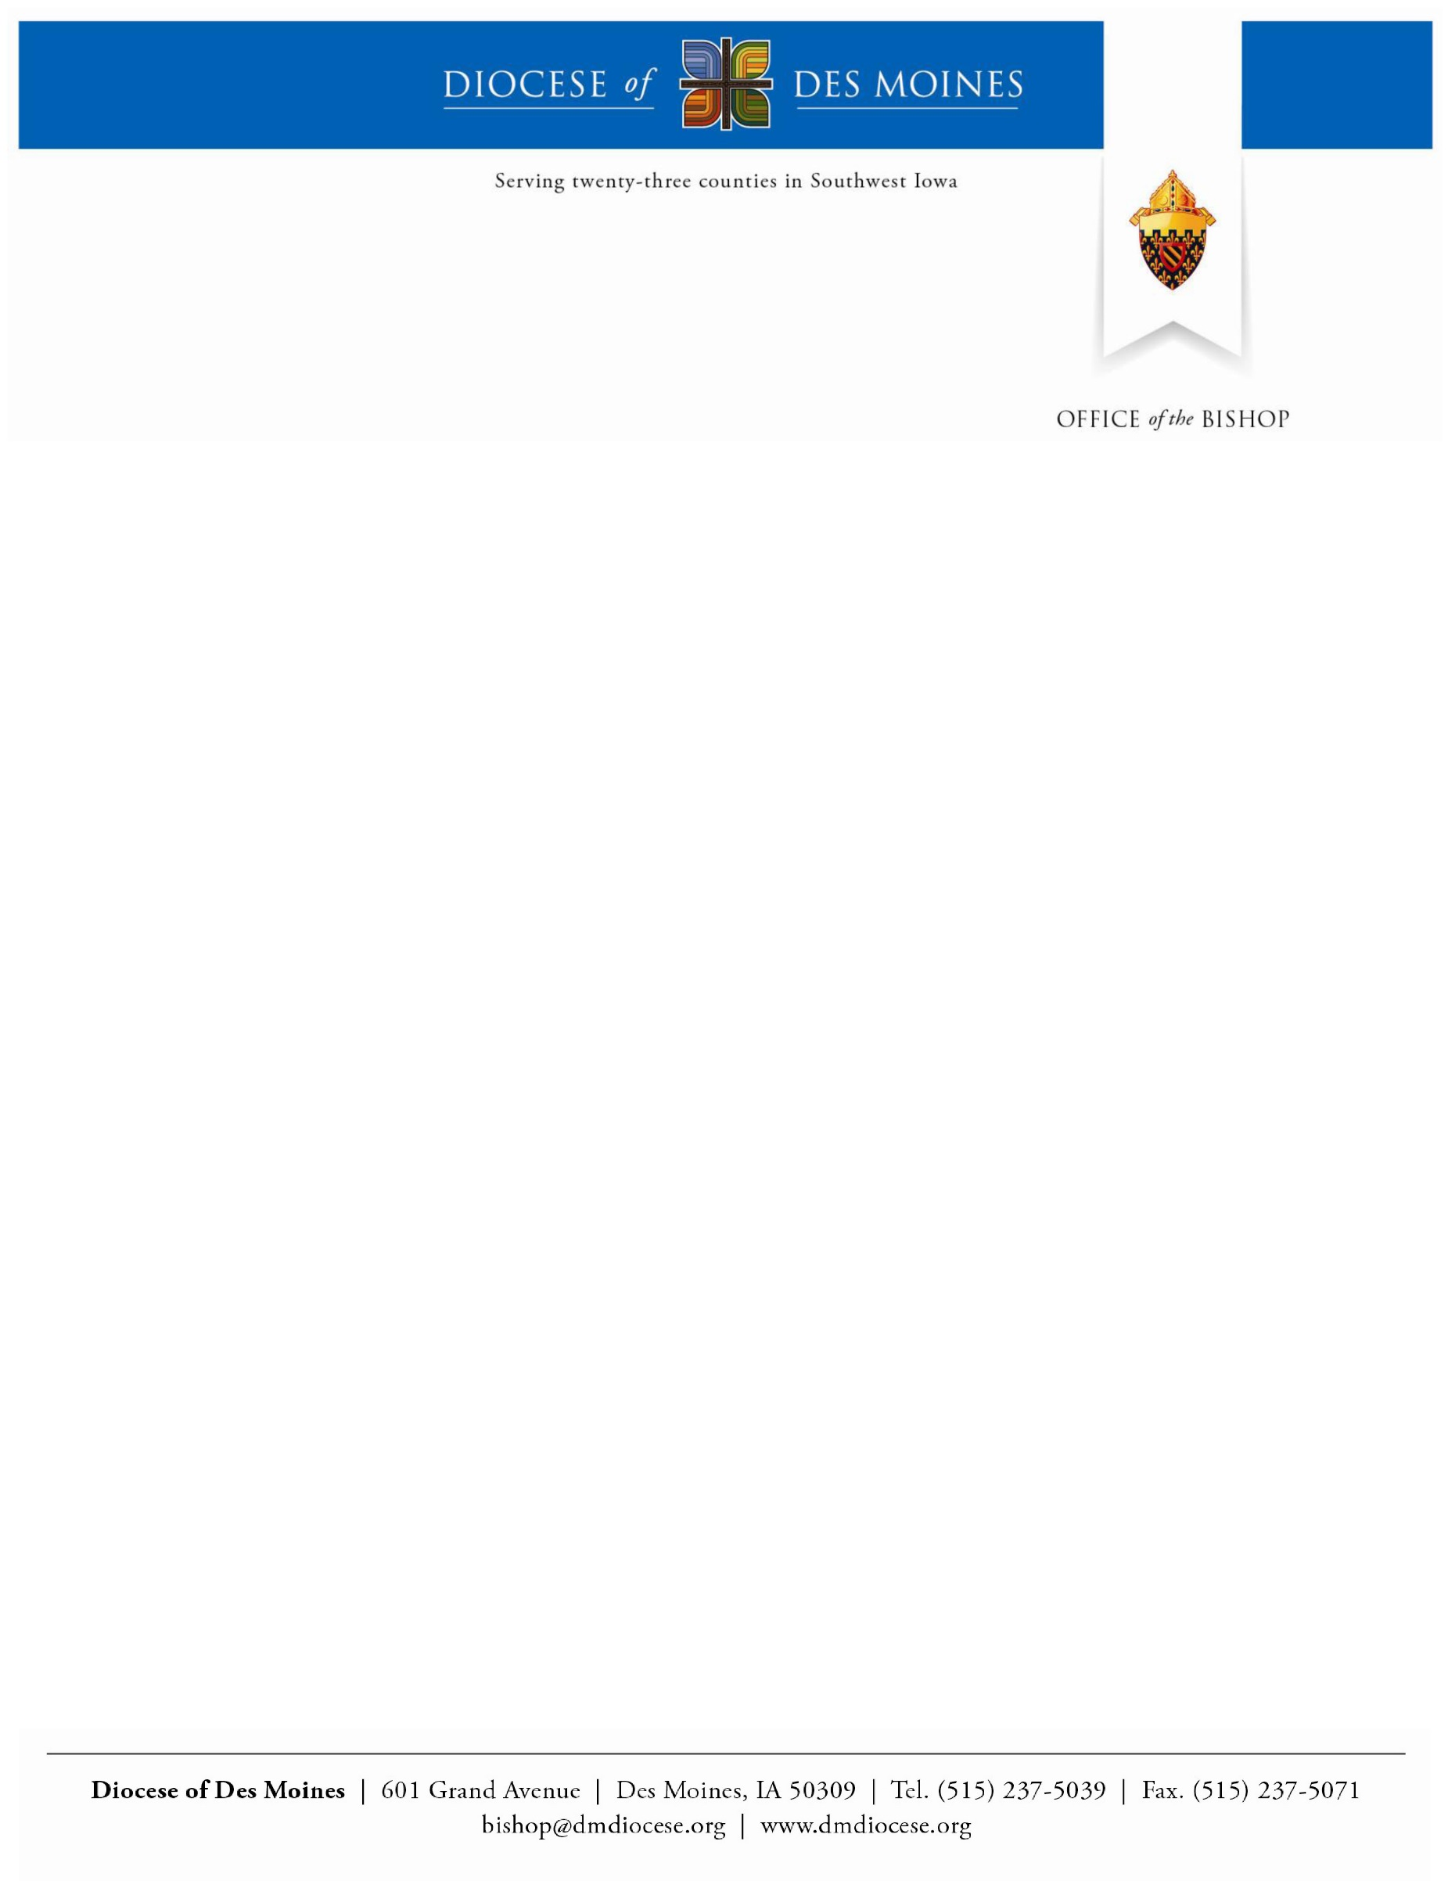

Diocesan Consultation for the XV Ordinary General Assembly of the Synod of Bishops
Executive Summary of the Preparatory Questionnaire
Diocese of Des Moines, Iowa

Note on Methodology:

In the Diocese of Des Moines multiple methods were used to distribute the preparatory questionnaire as widely as possible. The questionnaire was mailed to clergy, deacons, pastoral ministers, and key teen and young adult groups both in print and electronically, with a cover letter inviting them to participate and share the survey with others. The survey was posted online on the diocesan website and Facebook page, and it was shared with local Catholic radio. Bulletin announcements were provided to parishes with the encouragement to use these materials to promote the survey further.

The survey was available from April 15 until August 15. During that time, 281 individual responses were collected through the digital process. Fifty-four young adults participated in five local focus groups. Of those who responded to the question on age, a majority of the respondents were born between 1982 and 2003. Participants were from 31 different zip code regions, although the largest number of respondents came from zip codes in the Des Moines metro area. The vast majority of respondents are single with 8% of the respondents listing they are married. We decided to distribute the questions by rephrasing them and reducing the number to five key questions that apply to the whole survey. This approach proved successful due to the quality of the feedback applied to the entire survey and the lack of responses from people who were unsure of the questions. The design team studied the original questions, carefully constructing the edited questions for integrity, but also with the understanding that our ministerial experience would utilize the answers in multiple ways.

The questions we posed are:
- Is your voice heard by the Church? Where are you given opportunities to share your thoughts and perspectives?

What are the biggest challenges you face in living out your faith? The biggest opportunities?

What groups/movements/programs have been most meaningful to you in the Church? Outside of the Church?

Do you feel welcome to participate in the life of the Church? How so?
- How does the voice of the Church impact your discernment about the future, and questions about what you will do and who you want to be?

Once the responses were collected, a team of employees at our Pastoral Center began collating them into an executive summary. This team included our Director of Evangelization and Catechesis, Director of Marriage and Family Life, Director of Faith Journey (our professional adult formation program for teachers and lay ecclesial ministers), the current and former Directors of Vocations and two Directors of Campus Ministry. The team tried to identify patterns of response and indicate the frequency of certain ideas, as well as offer quotations that could help summarize trends. The executive summary responds to each question individually.

Response Summary:
Evaluating the situation:

(Q1) In what manner does the Church listen to the lived situations of young people?

There seems to be an even split between the group that says that the Church does listen to its young people and the group that says that the Church does not. It is paramount to note that the opportunities provided to young people to speak of their concerns and lived experience of the Church is at a local church – be it a youth group or some bible studies group. The essential problems with this, as some responses indicate, are two-fold. First, it requires one to be physically present at the local church. Second, it is structured in a setting where there is a leader of authority and concerns are heard but also dismissed very quickly.

Hispanics who attended predominantly Hispanic parishes felt their pastors were open to suggestions and felt the diocese was interested in their views. They cited the layout of the Encuentro Process and leadership opportunities on Hispanic advisory committees to the diocese.

A few responses did note that certain surveys, like this one, are electronic and made available on the internet in order to reach those who may not attend Church or who have fallen away; this, they observe, is a step in the right direction.

(Q2) What are the main challenges and most significant opportunities for young people in the United States?

The challenges seem to be four in kind. There are those who think that the main challenge facing them concerning their faith is a personal challenge. This group indicates that there are various difficulties in trying to be faithful, ranging from personal struggles, commitment to prayer, being influenced by the secularism of the world, or not being able to connect with others who share the same inclination towards being faithful.

Pertinent to the last point, there are two groups who find challenges in personal struggles: one which desires to be faithful to the Church’s teaching and cannot find others who share the same position in order to grow in faith, and one which opposes the Church’s teaching on certain matters, e.g. sexual teachings, who also indicated that they are unable to find others to share in those convictions.

The second kind of challenge indicated by a good amount of responses is what is perceived as the political side of the Church. The responses find the Church’s affiliation with political positions and agendas to be a struggle to take the Church seriously since the Church should not be in the political business.

The third kind of challenge is the struggle to find common grounds with the Church’s teachings in various matters. The one matter that comes up more than others is the Church’s teaching on human sexuality. Those who indicated that this matter is a challenge for them want the Church to affirm the modern positions concerning homosexuality.

The last challenge is the lack in ability to intellectually present their convictions to others. The responses indicate that there is a need for intellectual formation for those who have already established a firm spiritual base in their faith.

The positive opportunities that the responses identified are in retreats and Catholic group settings, i.e. Young Adult Groups in the Des Moines area, NCYC, Catholic Youth Camp, Kairos Retreats at the two Catholic High Schools, Christ Renews His Parish Retreats, and youth ministry. The respondents saw these as positive opportunities for them to grow and learn their faith.

(Q3) What kinds and places of group gatherings of youth, institutionalized or otherwise, have a major success within the Church, and why?

It appears the survey respondents read the question of “inside the church” and “outside the church” events as those that occur outside or inside a physical structure. For the purpose of this survey, we are combining the two responses under “inside the Church.”

These gatherings inside the Church that seem to have had major success:
- Christ Renews His Parish and CEW Retreats
- RCIA
- Youth ministry
- Seek College Conference by FOCUS
- Service programs set up by the parish
- Vacation Bible School
- Singing in the choir and other opportunities for liturgical ministry participation
- Mentoring youth at the local parishes
- Kairos Retreats for High School juniors
- World Youth Day
- NCYC
- NOVOS (Young Adult Group in the Des Moines area)
- Prolife groups and the March for life
- Catholic communities that serve the homeless
- Man-up program based in the Des Moines area that helps men grow in their faith
- EWTN and Iowa Catholic Radio
- Extraordinary Form Mass
- Catholic Youth Camp

(Q4) What kinds and places of group gatherings of youth, institutionalized or otherwise, have a major success outside the Church, and why?

These gatherings outside the Church seem to have had major success:
- Habitat for Humanity opportunities
- Civic and veteran organizations such as Jaycees or the American Legion
- Joining a group for a common cause such as regularly helping at a hospice, advocating on behalf of the immigrant or feeding the homeless
- Outreach to the poor such as volunteering with Big Brothers/Big Sisters or at the Iowa School for the Deaf
- YMCA as a model for helping grow healthy and active communities
- “Small towns are dying” was a reoccurring theme

(Q5) What do young people really ask of the Church in the United States today?

The responses to our diocesan survey were varied, but seemed that the most common request was for authenticity. As one respondent said, “Young people want something that is REAL.” Different respondents pointed to a seeming hypocrisy in the beliefs of the Church and in how she lives them out. Many requested a more positive witness, and help in guidance as to how to live out the Catholic faith on a daily, immediate level.

Another common request was for opportunities to build community (through bible studies, small faith sharing groups, a stronger sense of community during Sunday liturgies) and opportunities to learn to pray (through retreats and prayer opportunities). For the most part respondents expressed a feeling of isolation, peer pressure, and doubt about God’s existence and the possibility of a relationship with Him.

Among the respondents, there was a strong sense that the Church’s vision of morality was distinct from the secular, dominant vision. Respondents were evenly split between a request to strengthen the Church’s voice and to better support their efforts to live out the Church’s vision, or to change the Church’s vision to more closely resemble the secular view.

(Q6) What possibilities for participation exist in the United States for young people to take part in the life of the ecclesial community?

Respondents saw opportunities for participation mostly in service projects and in faith sharing groups. Others mentioned parish committees and ministry groups such as the choir or participation in technology/social media outreach. Many respondents admitted that they do not seek out possibilities for participation, and they expect that if they tried they would be welcome. A small group felt discouraged in that they did volunteer to participate in the life of the parish and they felt rejected.

In one focus group, the Church was disparagingly compared to evangelical Christian communities, which have a reputation of being much more welcoming and involving than the Catholic Church in their community.

Notably absent was a sense that worshiping as a member of the Body of Christ was a form of participation. No survey respondents or focus group member mentioned regular communal prayer as a form of participation.

(Q7) How and in what manner is contact made with young people who do not frequent Church surroundings?

This contact was not strong, and most survey respondents did not address this question. In looking at the focus groups, it seems that most of this contact is made through their peer group, having active young adult Catholics reach out to inactive young adults. It seems that at most parishes this effort is limited and unintentional.

Attracting those who no longer practice their Catholic faith was difficult. During the registration process for the focus groups, participants were strongly encouraged to bring those who no longer practice their faith or those who do not practice any faith. There was some success with the focus group participants, but the group who did the best only wanted to share why their Evangelical Church was better than the Catholic Church.

Parents, teens and young adults were encouraged to send the survey link to the same group as listed above however the results did not show many took the advantage of participating. Since we know there is a very large group labeled “the nones” it led the team to posit that either they did not feel the Church was authentic in her desire to listen to their opinion or that those entrusted to put the survey or focus group invite in the hands of “the nones” were reticent in their mission.

(Q8) How are families and communities involved in the vocational discernment of young people?

Again, it appears that this effort on understanding and practicing discernment is very limited. In some cases, men felt called to the priesthood but were actually discouraged by their families and their parish priests. Specifically they were told to “wait until they were older”.

Insofar as young adults approach vocational discernment, it seems they gain moral guidelines from the Church, which they recognize as helpful. A few respondents mentioned having spiritual directors. Most did not connect professional careers, or immediate decisions, as related to discernment.

One focus group participant, from the largest group assembled, asked, “Since we are all having a problem with this, perhaps this is a Church issue and priests need to show us how to do it.” This led me to ask several priests and youth ministry leaders near the end of the survey period how much time is spent on discernment and actually using that specific word. Very little dedicated time is given to activities that help a person discern God’s voice in their life. Furthermore, only a few had a similar broad perspective as Pope Francis regarding vocational discernment.

(Q9) How do schools and universities or other educational institutions (civil or ecclesial) contribute to young people’s formation in vocational discernment?

Universities and other educational institution provide opportunities for academic formation, which includes personal development. The collegiate experience on campus provides students with attitudes and skills that can contribute to responsible and global citizenship. Many of these institutions also provide or create the atmosphere for campus ministry. “Campus ministry gathers the Catholics on campus for prayer, worship, and learning in order that they might bring the light of the Gospel to illumine the concerns and hopes of the academic community” (Empowered by the Spirit: Campus Ministry Faces the Future). University and college ministries provide a wide range of programs to assist with the vocational discernment process.

Campus ministry staff and volunteers are living witnesses of the various forms of vocational ministries that students discern. By sharing our personal faith journeys, vocation discernment, and our response to God’s call with students, we provide the platform for ongoing vocational discernment; create the awareness of God’s calling, and opportunities to guide the students through prayer to discern their calling. Some of campus ministry programs are tactically geared towards discernment vocation – to religious life, priesthood, married and single blessedness. These programs open the door for students to freely ask questions, pray, and seek spiritual direction in the process of their discernment. Examples of these programs include vocation talks, vocation camps, prayer, and discipleship.

At Colleges and Universities, like Mercy College of Health Sciences, where class time and emphasis is placed on more than technical expertise (an emphasis on a broad training in the Liberal Arts and Servant Leadership), the human understood as an integral unity begins to come into focus. Rather than seeing themselves and their lives as a merely potential cog in an employment machine, or a producer of wealth to expend within a universe of consumption, young people can start to understand their lives as containing a teleological purpose. From there, they see that everything—from career choice to how they interact with people on an everyday level—is an interconnected potentiality, which their lives activate through the informed choices they make about their futures.

No matter the choices and decisions young people make regarding their vocation our goal has been to help them embrace Jesus’ call for us to serve our brothers and sisters in a selfless way in their home and their professional life (Mark 10:44-45).

(Q10) In what manner are you taking into account the cultural changes resulting from the development of the digital world?

The Diocese of Des Moines continues to intentionally enter into the digital landscape through a systematic strategy that includes all Diocesan offices. However, many of the challenges that are encountered are related to the cultural changes that affect the creation of community. Many millennials surveyed, and participating in focus groups, see community as something they create: not something larger than themselves that includes them as a member. This leads to isolation on many fronts: politically, socially, and ecclesially, and to the following challenges:
- I participate in the parish community that I want rather than the parish community that is in my neighborhood.
- My social community is formed by my friendships and rarely includes others who do not possess a similar world view.
- Matters of Catholic traditionalism and progressivism create ecclesiological battles that support suspicion over understanding.

The survey and focus groups do point that many millennials could participate more if they desire, but find value in endeavors outside the Church.
(Q11) How can World Youth Days or other national or international events become a part of ordinary pastoral practice?

The Diocese of Des Moines has experienced significant benefits through the participation in World Youth Day, the National Catholic Youth Conference (NFCYM), the Seek Conference (FOCUS), as well as the Steubenville Summer Conferences for high school teens. The diocese tested a new national program, One Bread One Cup Conference, where teens and chaperones grow in their love of the sacred liturgy and their skill set in one of the areas of emphasis.

We have found that encouraging participation, as well as committing diocesan staff and resources, benefits the diocese in the following ways:
1) It is an investment in future leaders of our diocese,
2) Growth in emerging ministries such as young adult ministry and Hispanic ministry, and,
3) Growth in our parishes as teens and young adults return to their parishes engaged in their faith and with a desire to share that with others.

The Diocese of Des Moines will continue to plan, promote and accompany teens, young adults and chaperones to international and national Catholic events. Furthermore, we have begun local opportunities for those who cannot attend to participate. This began with a local version of the March for Life and the Fortnight for Freedom advocacy events. During the past World Youth Day, we offered a local stateside celebration at the parish pilgrimage site where St. John Paul II visited in 1979.

(Q12) In what manner is your diocese planning experiences for the pastoral vocational program for young people?

As part of the response from the Convocation of Catholic Leaders, the Diocese of Des Moines is launching a new endeavor called The New Moment. This includes certain actions in which Church leaders first embrace the ongoing commitment for personal and communal conversion in the Spirit of the Lord Jesus and the ongoing need to be missionary disciples in one’s outreach to others. In a very significant way, the diocese will focus its attention on millennials. The messaging of the plan is as follows:

Embrace – through personal conversion and witness (clergy and lay leaders first)

The Joy of the Gospel calls us to be missionary disciples, which means…
- Discipleship – Involves a deep relationship with Jesus as His follower. We foster this by developing of opportunities to grow closer to Jesus and imbibe the Gospel message.
- Missionary -- From conversion and deepening of our relationship with Jesus, we commit ourselves to be sent on mission. Faith is meant to be shared.

Emphasize—Accompaniment, through a listening posture, the call is especially to pivot to youth and young adults:
- Accompaniment – Our task is to be Relationship Builders to facilitate their walk with Jesus. In our times, this calls the church community to be a “field hospital”.

- Ministry Pivot – While the whole body of Christ needs our witness, of particular focus should be those in later high school through mid-30s, which are categorized as Millennials.

Empower – others to have a profound relationship with Jesus and witness to that reality:
- Ministry Cycle – The outcome is a continuing cycle of personal conversion, witness and relationship building to empower others to serve as Missionary Disciples and spread the Joy of the Gospel.

(Q13) How much time and in what manner do clergy and other formators provide for personal spiritual guidance?

Currently we have 16 spiritual directors listed in our directory for the Diocese of Des Moines. Of the 16, five are priests, two are religious sisters and nine are lay people. Currently four additional lay people are in formation. The Diocese has three centers dedicated to spiritual guidance: The St. Thomas More Center, whose emphasis is primarily on teens and young adults, the Creighton University Retreat Center, which holds a variety of retreats including Kairos High School Retreat for juniors at Dowling Catholic High School and St. Albert High School, and the Emmaus House whose staff is dedicated to personal spiritual guidance through a variety of programming and individual spiritual direction.

Our Director of Vocations along with the two chaplains at our high schools invest their time and talent in personalized spiritual direction.

(Q14) What initiatives and opportunities for formation are in place for those who provide pastoral vocational guidance?

Currently laity, discerning a call to the ministry of spiritual direction, are directed to one of two programs although they are free to choose others as well. The two recognized as offering a sound formation in spiritual direction include: The Franciscan Spirituality Center in La Crosse, Wisconsin, and the Creighton University Spirituality Program with a focus on spiritual direction and directed retreats. Our clergy have access to programming through the Vocation office.

(Q15) What personal guidance is offered in seminaries?

In the process of discernment toward priesthood, the candidate is taught how to pray toward discernment. This process of prayer and discernment is used for the man himself to discern whether to continue to move toward Holy Orders or not. The benefit of having the candidate learn and use this discernment is that he can help teach others to use prayer and discernment. Vocations ministry is a ministry of discernment. The seminaries are dedicated to discernment. One of the great tools that the Diocese of Des Moines uses is that of sending our men to the Institute of Priestly Formation (IPF) in Omaha for the summer before first theology. This program uses the Ignatian discernment of spirits to help the men grow in their prayer lives. A seminarian after this program should be able to help others to some extent with discernment.

Some other factors that benefit our seminarians include:
- Personal guidance permeates the process of seminary formation.
- A seminarian has a spiritual director along with a person who acts as a formation director.
- A good path forward would be to help future priests understand that they, as the priest, are the first people that one goes to for vocational guidance.

(Q16) How does your community care for young people who experience extreme violence and accompany them in various ways in their life?

Currently we have one Hispanic bilingual priest and a few deacons who are engaged in prison ministry at local county jails. We have a group of well-formed volunteers who run the Residents Encounter Christ (REC) Retreat at the local women’s prison. Although we do not have a specific program for gang violence, we collaborate with the Center for Social Ministry, which runs formation programming on poverty and urban immersion. The idea is to have missionary disciples in these neighborhoods helping so that those enticed into gangs might see a brighter future apart from gangs. Our Catholic Charities also provides counseling services for those trapped in the violence of gangs. Finally, we partner with a residential Catholic treatment program for addicts titled St. Gregory Retreat Center.

(Q17) What formation is offered to support the engagement of young people in society and civil life, for the common good?

For teens and young adults, there are multiple options at the parish and diocesan level in which to engage in works of advocacy and formation for the common good. Examples include:
- The service component of the Diocesan Confirmation Preparation Program. The ordinary age for Confirmation is sophomore in high school.
- The USCCB Respect Life Program
- Catholic Relief Services Rice Bowl
- Local diocesan aid program for seminarians’ education in Nigeria
- Local Catholic Charities programs that allow for formation and service in many different areas of need
- JWalking – an RCIA type program for teens sponsored by JustFaith
- March for Life and pro-life advocacy
- The Iowa Catholic Conference is shared among many teens through youth ministry to stay engaged in local legislative matters from a Catholic perspective. This includes the materials used by the diocese for evaluating public officials running for office.
- Mary’s Meals – an outreach to international communities who do not have enough food.
- Clean energy public policy and other environmental issues from a Catholic perspective.

(Q18) In a world which is greatly secularized, what pastoral activities are most effective for continuing the journey of faith after the Sacraments of Christian Initiation?

There are two words commonly used by those who attend teen or young adult programming: it is authentic and it is relevant to my life. Many people in our survey and focus groups identified Saint John Paul II as one they felt was authentic. Even when they disagree with his teaching, they still ponder his message because of the strength of his Catholic identity. We need to stop being concerned always about answering questions and focus on framing the questions in a way that leads the teens and young adults into mission.

